How to enable the access to ClientLibs under apps folder

The client libraries used to be kept under /etc folder in Adobe Experience Manager(AEM) and allowed to be accessed from outside through dispatcher by enabling the anonymous access.

In order to better isolate code from content and configuration , it is recommended to locate the client libraries under /apps folder in latest AEM versions.

The /apps folder access is restricted for anonymous users and also restricted the access through dispatcher.

To enable client libs to be loaded outside via dispatcher, we have a client library proxy servlet which allows the client libs to be loaded on the page.

**Enabling the access to clientlibs:**

1. Go to client libs folder that you want to enable access for
2. Add a property to the client lib folder, with name “allowProxy” , type “Boolean” and value as true

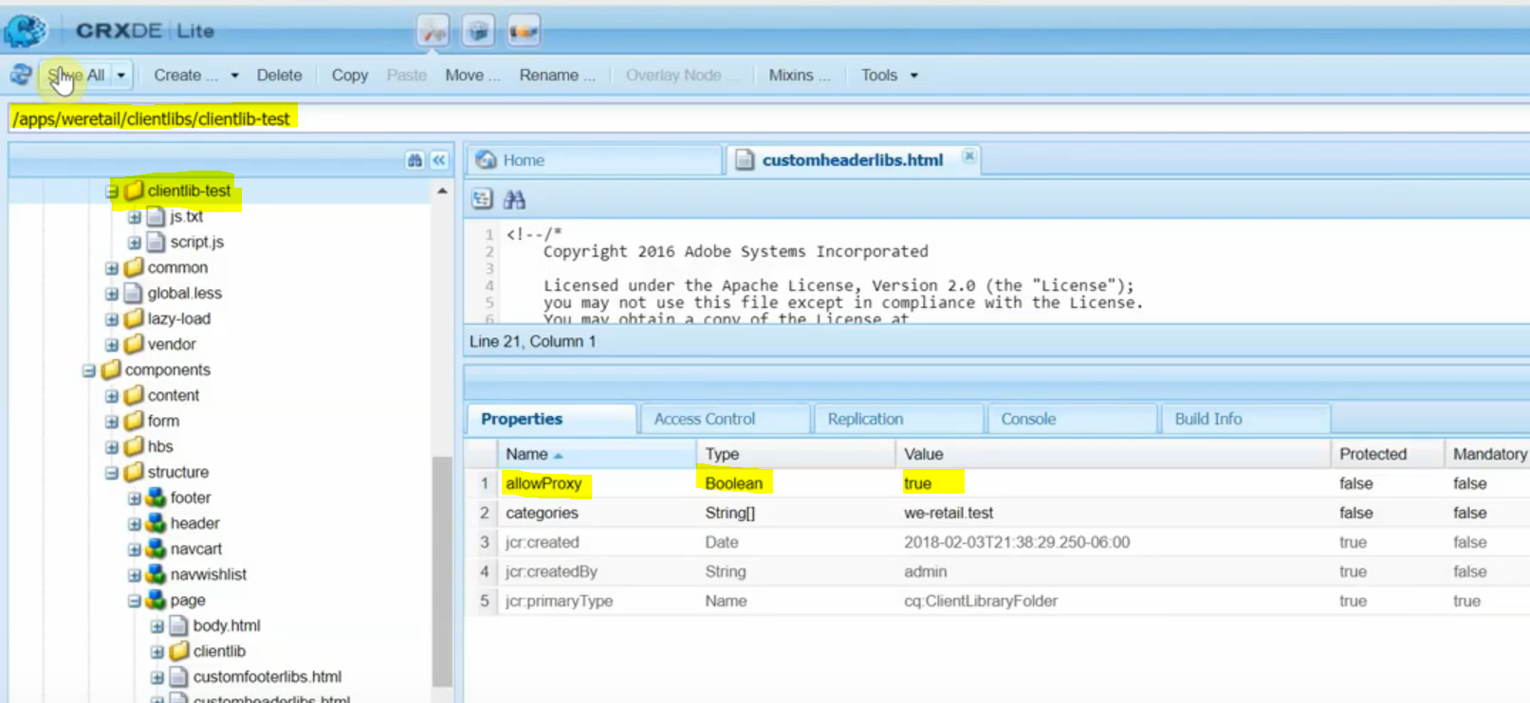

These are the changes from client libs folder end.

Note: Client library proxy servlet would expose the client libs via etc clientlib folder, so the final URL looks like this.

Means that the clientlibs are proxied via etc clientlibs.



As we can see the source URL is having extension as clientlibs after etc, so when this is access via dispatcher, this extension should be allowed from dispatcher end as well.

**Enabling extension from dispatcher:**

1. Go to dispatcher.any file and find the filters rule.
2. Add clientlibs value to the existing extension values.

